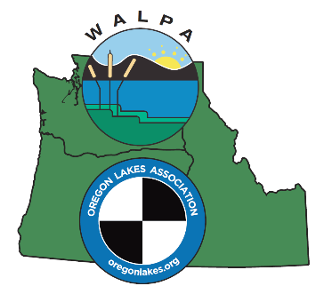
Oregon Lakes Association/Washington Lake Protection Association – 2018 Annual Meeting Auction/Raffle
Donation Confirmation
We would like to confirm our participation in your raffle/auction by donating the following item(s) or services to your organization. We understand the donation will be raffled or auctioned at the 2018 Annual Conference, PNW Lakes in a Changing World, September 26-28, 2018, at DoubleTree By Hilton Hotel, Portland, Oregon.
Item Donated w/ Retail Value ____________________________________________________________________
Description for meeting flyer: ____________________________________________________________________
____________________________________________________________________
____________________________________________________________________
Limitations, terms, conditions (e.g. expiration date):
______________________________________________________________________________________________________________________________________________
Donor Information (Please print) Date ________________________
Donor (First and Last Name) _____________________________________________
Business Name ________________________________________________________
Address ____________________________________________________________
City, State, Zip _______________________________________________________
Phone/Email ________________________________________________________
Solicited by _________________________________________________________
Ship Auction / Raffle Items to:
OLA/WALPA Conference Date Shipped ___________
ATTN: Stephen Wille Date Received __________
704 N.E. Countryside Drive
Vancouver, Washington 98684-4115
503.880.4453 Special Shipping or Pick-up Required? Y__/No__
SAWille1@gmail.com

Thank you for your support. We appreciate your donation, which is tax deductible to the fullest extent provided by law. Our 501(c)3 tax identification number is: available on request.

